Earth, Moon, and Sun Study Guide
______ 1. All objects are attracted to each other by the force of
a. weight. c. inertia.
b. mass. d. gravity.
______ 2. The strength of the force of gravity depends on
a. the masses of the objects and their speeds.
b. the masses of the objects and the distance between them.
c. the weight of the objects and their speeds.
d. the masses of the objects and their weights.
______ 3. A pattern or grouping of stars imagined by people to represent a figure is a
a. star chart. c. seasonal pattern.
b. mythological object. d. constellation.
______ 4. The tendency of a moving object to continue moving in a straight line or a stationary object to remain in place is called
a. orbital speed. c. inertia.
b. mass. d. gravity.

______ 5. The constellations seem to move as the seasons on Earth change. What causes this?
a. Like the moon, the stars move around Earth.
b. As Earth revolves around the sun, we have a different view of the stars.
c. As the Earth rotates on its axis, we see different parts of the sky.
d. Just as the seasons on Earth change, so do the seasons on stars.
Completion
Fill in the line to complete each statement.
6. The force that pulls the moon toward Earth is called ____________________.
7. If you are in a car that stops suddenly, your body keeps moving because it has ____________________.
8. A tide with the least distance between low and high tides is called a(n) ____________________ tide.
True or False
If the statement is true, write true. If it is false, change the underlined word or words to make the statement true.
____________ 9. Newton’s law of universal gravitation states that every object in the
universe attracts every other object.
Earth, Moon, and Sun (continued)
Essay
10. Explain how inertia and gravity combine to keep Earth in its orbit.

Using Science Skills
Use the figure below to answer the following questions in the spaces provided.
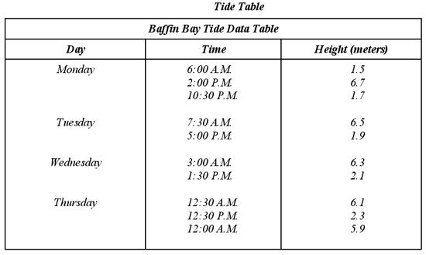
11. Describe how the height of the tides changes from Monday to Thursday.

12 Are the tides approaching a spring tide or a neap tide? Explain.

13. How many tides will occur on Monday? How many are high tides? How many are low tides?

Essay
14. Explain why spring tides are higher than all other tides.

